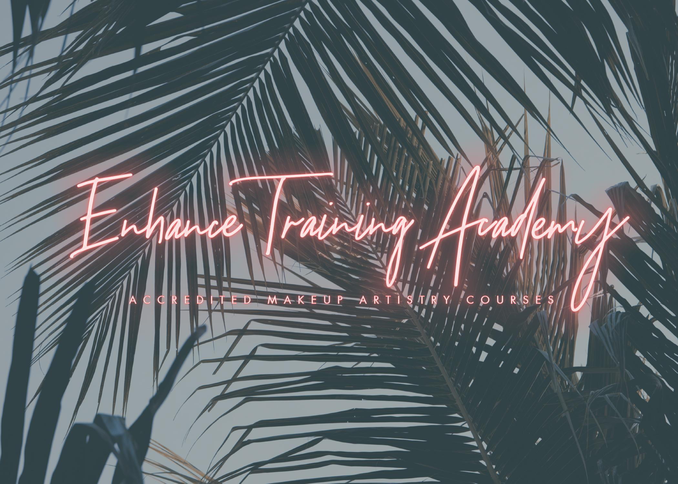
Hello and welcome to Enhance Training Academy!
Thankyou for expressing your interest in our training facilities and our accredited courses. We are always expanding and improving our courses so if there is anything course wize that you cant see below, please do feel free to email and ask us any questions you have.
All our courses are one to one training. There for you get 100% of your tutors time and attention. We think our learners benefit from a one to one experience rather than a group environment. We can suit your training sessions to your learning style and preference and also to your speed!
We are the only Beauty Guild Accredited centre in Halifax! And aim to always be the best. Our student recommendations can be found on our Facebook page.
We also work alongside PAYL8R to offer finance options alongside all our courses.
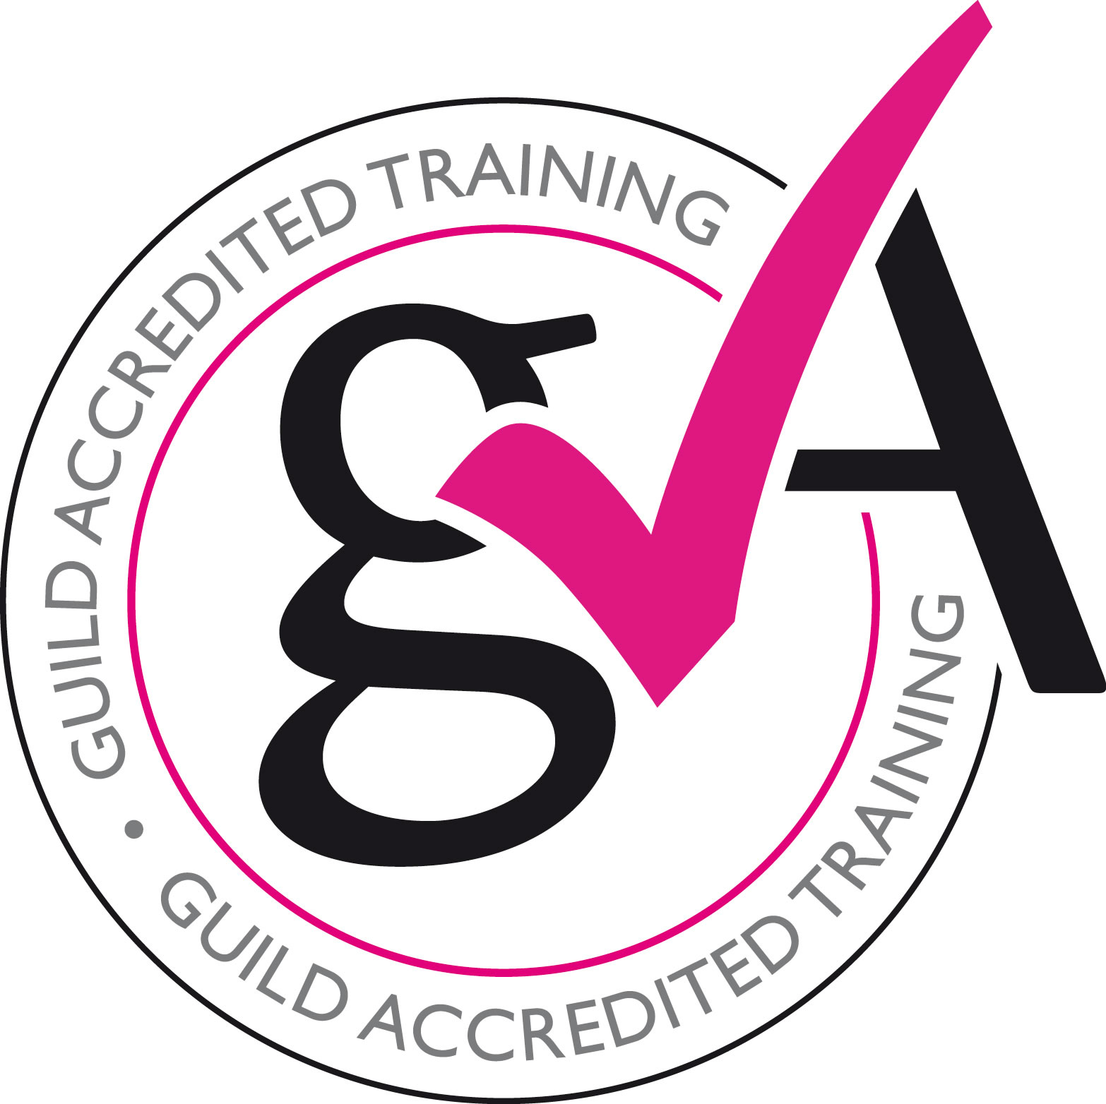

Title: Two Day Make-Up Artistry Course
Price: £500
Summary:
This course covers the application of make-up to the face, eyes and lips as well as how to perform a facial cleanse apply strip and individual lashes. The course also shows you how to adapt your treatment to suit varying clients’ needs. Resources with clear diagrams, images, video clips and voice over are included to give you the best possible learning experience. Reception, consultation and aftercare guidance is covered as well as contra-indications to treatment. The course includes online theory as well as a practical training session at Enhance Training Academy, designed to give you the confidence and ability to offer a full make-up treatment.
Qualification: GTi Award Course
Accreditation: Guild of Beauty Therapists
Course Type: Theory and practical Theory Hours: Approximately 14 hours of study time will be required to complete the theory element of this course.
Practical Hours: Approximately 6 hours of practical training will be required to complete your assessment day.
Examination: GTi online examinations and one day of practical assessment

PLEASE NOTE THIS COURSE IS NOT FOR BEGINNERS.

Title: Three Day Make-Up Artistry Course
Price: £600
Summary:
This course covers the application of make-up to the face, eyes and lips as well as how to perform a facial cleanse apply strip and individual lashes. The course also shows you how to adapt your treatment to suit varying clients’ needs. Resources with clear diagrams, images, video clips and voice over are included to give you the best possible learning experience. Reception, consultation and aftercare guidance is covered as well as contra-indications to treatment. The course includes online theory as well as a practical training session at Enhance Training Academy, designed to give you the confidence and ability to offer a full make-up treatment.
Qualification:
GTi Award Course
Accreditation:
Guild of Beauty Therapists
Course Type: Theory and practical Theory Hours: Approximately 14 hours of study time will be required to complete the theory element of this course.
Practical Hours: Approximately 10 hours of practical training will be required to complete your assessment day.
Examination : GTi online examinations and one day of practical assessment

PLEASE NOTE THIS COURSE IS NOT FOR BEGINNERS.

Title: Four Week Make-Up Artistry Course
Price: £850
Summary:
This course covers the application of make-up to the face, eyes and lips as well as how to perform a facial cleanse apply strip and individual lashes. The course also shows you how to adapt your treatment to suit varying clients’ needs. Resources with clear diagrams, images, video clips and voice over are included to give you the best possible learning experience. Reception, consultation and aftercare guidance is covered as well as contra-indications to treatment. The course includes online theory as well as a practical training session at Enhance Training Academy, designed to give you the confidence and ability to offer a full make-up treatment.
Qualification: GTi Award Course
Accreditation: Guild of Beauty Therapists
Course Type: Theory and practical Theory Hours: Approximately 14 hours of study time will be required to complete the theory element of this course.
Practical Hours: Approximately 12 hours of practical training will be required to complete your assessment day.
Examination: GTi online examinations and one day of practical assessment.
WEEK 1 - Day/Natural makeup demonstration
WEEK 2 - Day/Natural makeup assessment
WEEK 3 - Evening/Glam makeup demonstration
WEEK 4 - Evening/Glam makeup assessment

Title: Six Week Make-Up Artistry Course
Price: £1000
Summary:
This course covers the application of make-up to the face, eyes and lips as well as how to perform a facial cleanse apply strip and individual lashes. The course also shows you how to adapt your treatment to suit varying clients’ needs. Resources with clear diagrams, images, video clips and voice over are included to give you the best possible learning experience. Reception, consultation and aftercare guidance is covered as well as contra-indications to treatment. The course includes online theory as well as a practical training session at Enhance Training Academy, designed to give you the confidence and ability to offer a full make-up treatment.
This course also includes a festival workshop including glitter making session and body painting.
Qualification:
GTi Award Course
Accreditation:
Guild of Beauty Therapists
Course Type:
Theory and practical Theory Hours: Approximately 14 hours of study time will be required to complete the theory element of this course.
Practical Hours:
Approximately 18 hours of practical training will be required to complete your assessment day.
Examination: GTi online examinations and one day of practical assessment

COURSE STRUCTURE -
WEEK 1 - Day/Natural makeup demonstration
WEEK 2 - Day/Natural makeup assessment
WEEK 3 - Evening/Glam makeup demonstration
WEEK 4 - Evening/Glam makeup practical
WEEK 5 - Evening/Glam makeup assessment
WEEK 6 - Advanced Eye Workshop

Title: Eight Week Make-Up Artistry Course
Price: £1425
Summary:
This course covers the application of make-up to the face, eyes and lips as well as how to perform a facial cleanse apply strip and individual lashes. The course also shows you how to adapt your treatment to suit varying clients’ needs. Resources with clear diagrams, images, video clips and voice over are included to give you the best possible learning experience. Reception, consultation and aftercare guidance is covered as well as contra-indications to treatment. The course includes online theory as well as a practical training session at Enhance Training Academy, designed to give you the confidence and ability to offer a full make-up treatment.
This course also includes a halloween or festival workshop including glitter making session and body painting. Advanced eye techniques class is also included.
Qualification: GTi Award Course
Accreditation: Guild of Beauty Therapists
Course Type: Theory and practical Theory Hours: Approximately 14 hours of study time will be required to complete the theory element of this course.
Practical Hours: Approximately 24 hours of practical training will be required to complete your assessment day.
Examination: GTi online examinations and one day of practical assessment

WEEK 1 - Day/Natural makeup demonstration
WEEK 2 - Day/Natural makeup practical
WEEK 3 - Day/Natural makeup assessment
WEEK 4 - Evening/Glam makeup demonstration
WEEK 5 - Evening/Glam makeup practical
WEEK 6 - Evening/Glam makeup assessment
WEEK 7 - Advanced Eyes Workshop
WEEK 8 - Festival or Halloween Workshop

Title: Twelve Week Accredited Make-Up Artistry Course
Price: £2000
Summary:
This course covers the application of make-up to the face, eyes and lips as well as how to perform a facial cleanse apply strip and individual lashes. The course also shows you how to adapt your treatment to suit varying clients’ needs. Resources with clear diagrams, images, video clips and voice over are included to give you the best possible learning experience. Reception, consultation and aftercare guidance is covered as well as contra-indications to treatment. The course includes online theory as well as a practical training session at Enhance Training Academy, designed to give you the confidence and ability to offer a full make-up treatment.
Course also includes industry sessions, festival themed lessons, body paint, Halloween lessons, SPFX training and covers the ins and outs of makeup artistry as a profession and self employment within the makeup industry.

Qualification: GTi Award Course
Accreditation: Guild of Beauty Therapists
Course Type: Theory and practical Theory Hours: Approximately 14 hours of study time will be required to complete the theory element of this course.
Practical Hours: Approximately 36 hours of practical training will be required to complete your assessment day.
Examination: GTi online examinations and one day of practical assessment

COURSE STRUCTURE -
WEEK 1 - Day/Natural makeup demonstration
WEEK 2 - Day/Natural makeup practical
WEEK 3 - Day/Natural makeup assessment
WEEK 4 - Evening/Glam makeup demonstration
WEEK 5 - Evening/Glam makeup practical
WEEK 6 - Evening/Glam makeup assessment
WEEK 7 - Advanced Eyes Workshop
WEEK 8 - Advanced Eyes practical
WEEK 9 - Advanced Eyes assessment
WEEK 10 - Festival makeup demonstration
WEEK 11 - Halloween makeup demonstration
WEEK 12 - Industry Day

Title: Sixteen Week Accredited Make-Up Artistry Course
Price: £2850
Summary:
This course covers the application of make-up to the face, eyes and lips as well as how to perform a facial cleanse apply strip and individual lashes. The course also shows you how to adapt your treatment to suit varying clients’ needs. Resources with clear diagrams, images, video clips and voice over are included to give you the best possible learning experience. Reception, consultation and aftercare guidance is covered as well as contra-indications to treatment. The course includes online theory as well as a practical training session at Enhance Training Academy, designed to give you the confidence and ability to offer a full make-up treatment.
Course also includes industry sessions,festival themed lessons, body paint, Halloween lessons, SPFX training and covers the ins and outs of makeup artistry as a profession and self employment within the makeup industry.
Qualification: GTi Award Course
Accreditation: Guild of Beauty Therapists
Course Type: Theory and practical Theory Hours: Approximately 14 hours of study time will be required to complete the theory element of this course.
Practical Hours: Approximately 48 hours of practical training will be required to complete your assessment day.
Examination: GTi online examinations and one day of practical assessment

WEEK 1 - Day/Natural makeup demonstration
WEEK 2 - Day/Natural makeup practical
WEEK 3 - Day/Natural makeup assessment
WEEK 4 - Evening/Glam makeup demonstration
WEEK 5 - Evening/Glam makeup practical
WEEK 6 - Evening/Glam makeup assessment
WEEK 7 - Advanced Eyes Workshop
WEEK 8 - Advanced Eyes practical
WEEK 9 - Advanced Eyes assessment
WEEK 10 - Festival makeup demonstration
WEEK 11 - Festival makeup practical
WEEK 12 - Festival makeup assessment
WEEK 13 - Halloween makeup demonstration
WEEK 14 - Halloween practical
WEEK 15 - Halloween assessment
WEEK 16 - Industry day

